**Name:**

**Dawood Sarfraz**

**Roll no:**

**20p-0153**

**Section:**

**BSCS-5B**

**Computer Networks Lab**

**Home Work 03**

**FAST-NUCES Peshawar Campus**

**TASK 01:** Setting Router Modes on 2600 Series Routers

**1)User Mode:** with command of show version

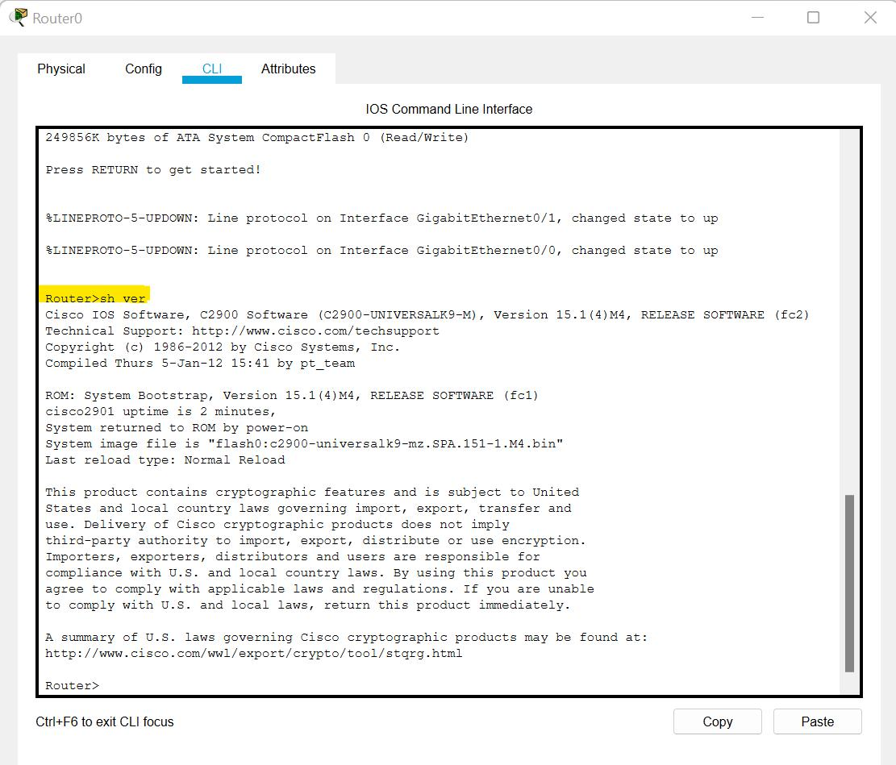

**2)privileged Mode:**

Entering privilege mode from user mode with enable command and can go back to user mode by writing exit.

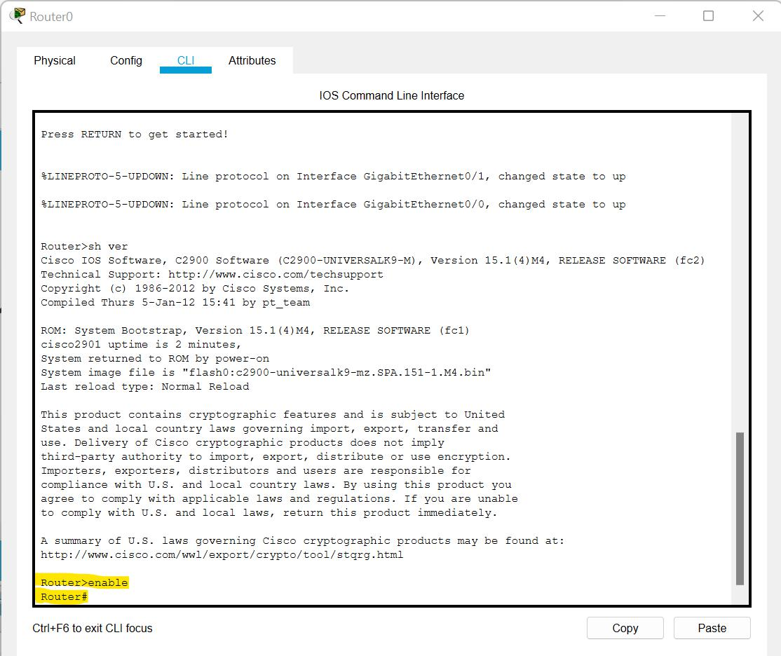

**3) Global Configuration mode:** We can exit this mode by writing Exit.

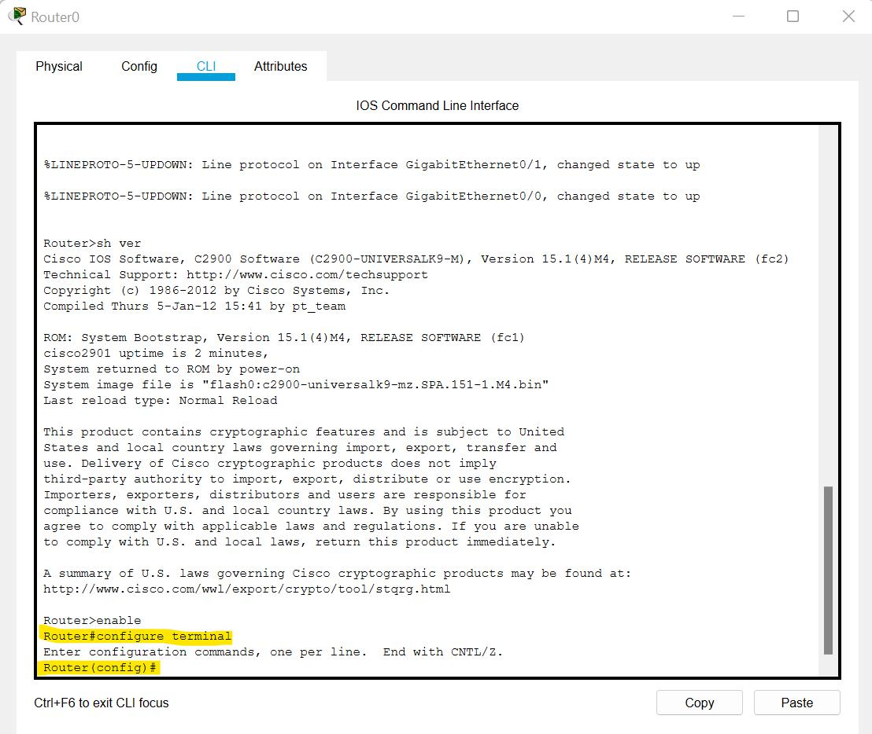

**4) Interface Configuration:**

We can enter interface configuration by writing interface <interface name + number> and can go back by writing exit.

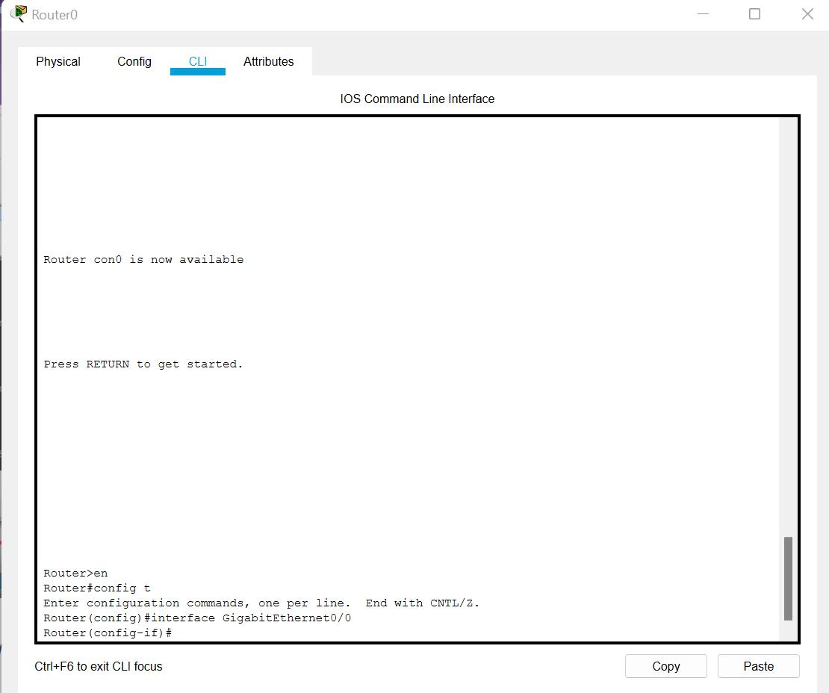

**TASK 2:** Changing Hostname of the Router

Initially a default hostname of router is set to router so if we want to change hostname we have to go to CLI of router and we have switch to Global Configuration mode. After switching to Global configuration mode we have to write command hostname <Name which we want to set>. And the hostname will be changed.

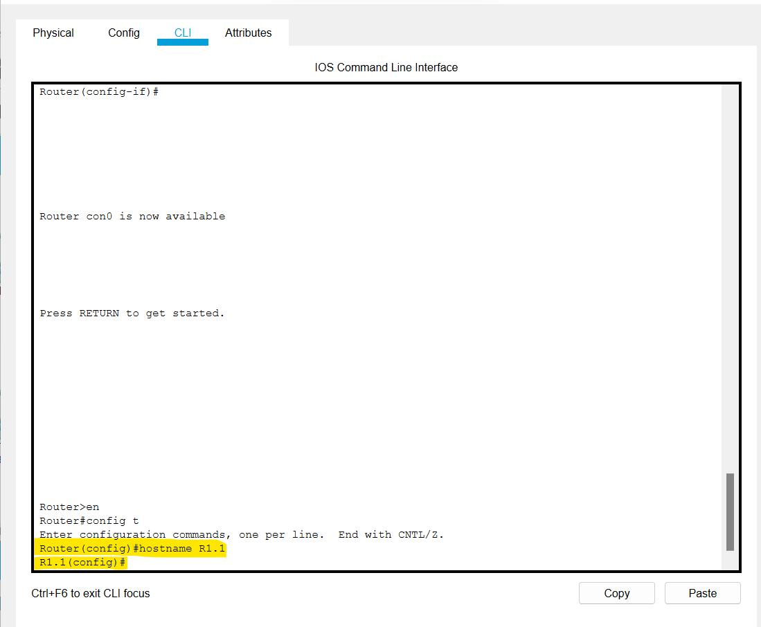

**TASK 3:** Configuring Date and Time on the Router (Clock Set Command)

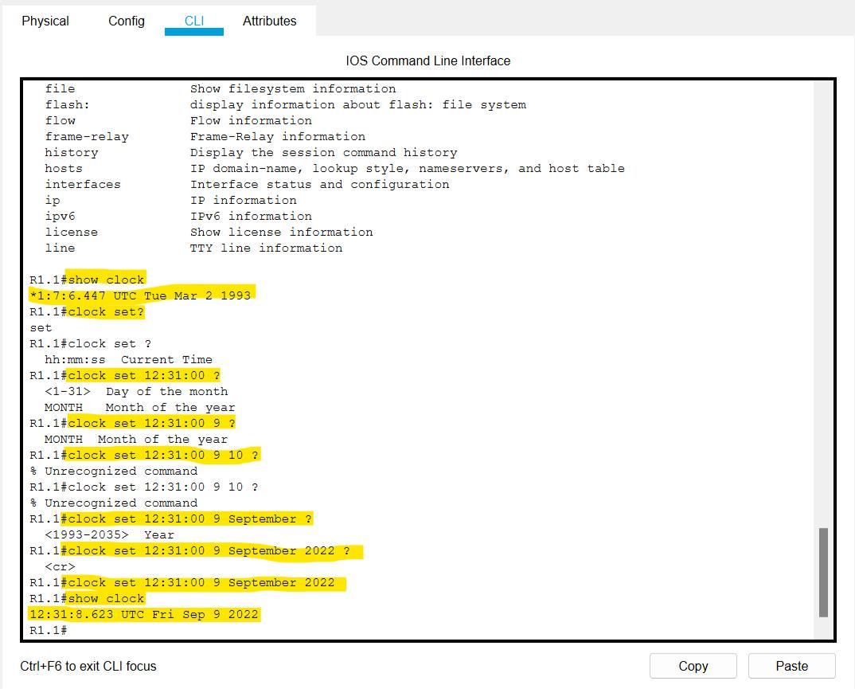

**TASK 4:**

Setting a banner on the Router

When anyone connects to the router, the banner appears before the login prompt.

For setting banner we have to get in Global Configuration mode first.

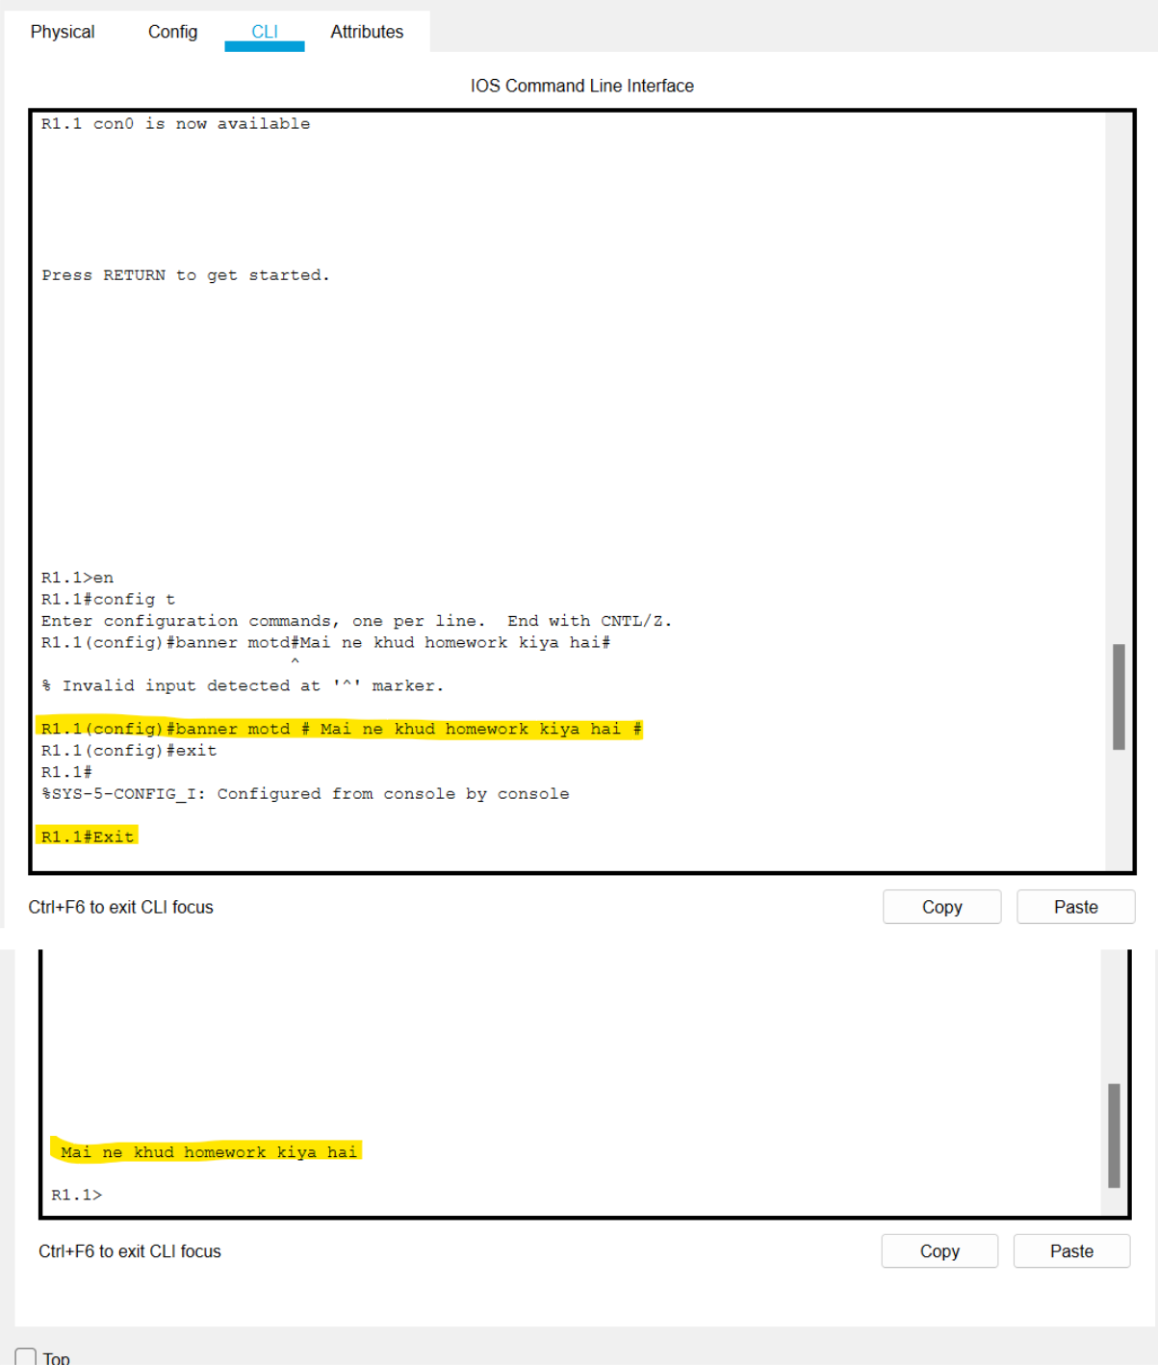

**TASK 5:** Displaying the Router’s Running-Configuration and Start-Up Configuration.

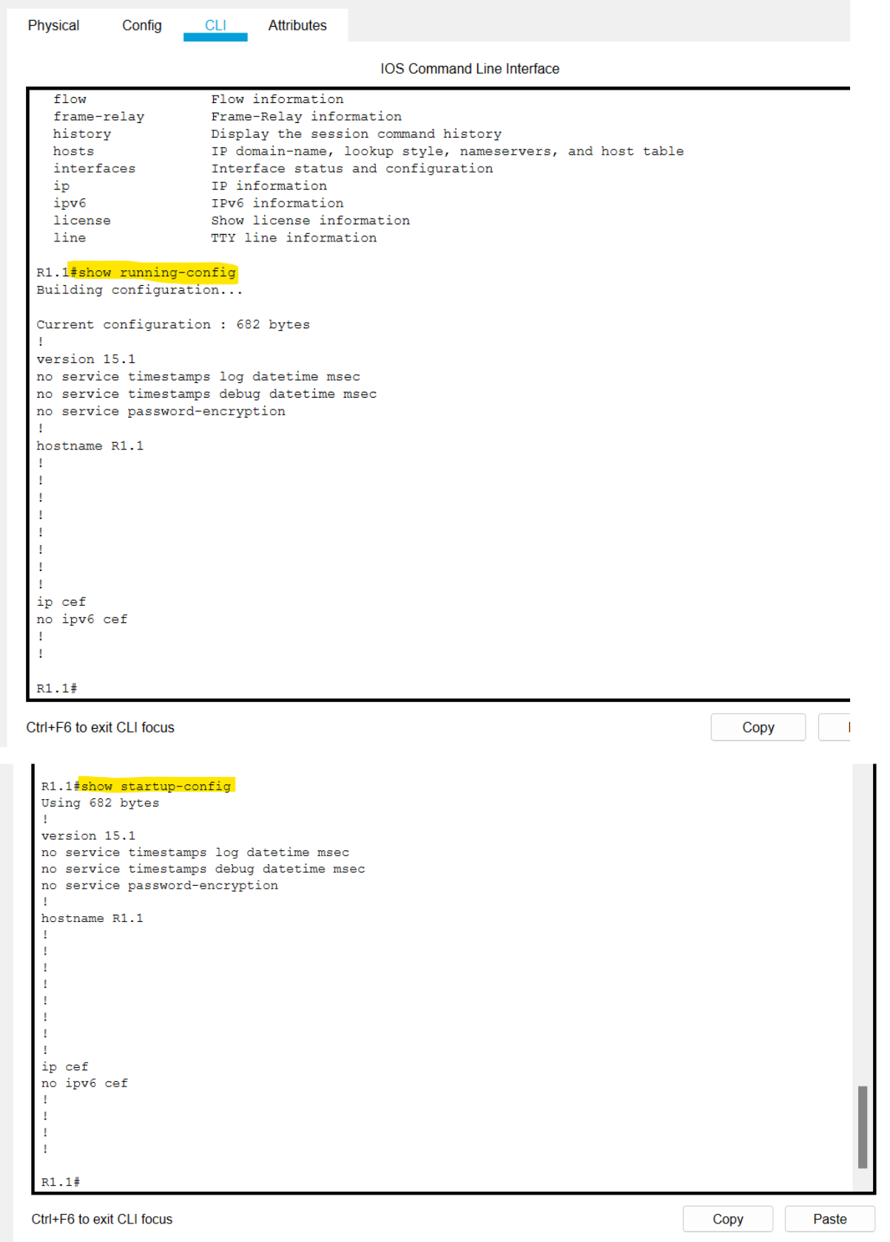

1. Enable Password and Enable Secret Password with the Encryption Techniques/Levels

=>Password For Privileged Mode

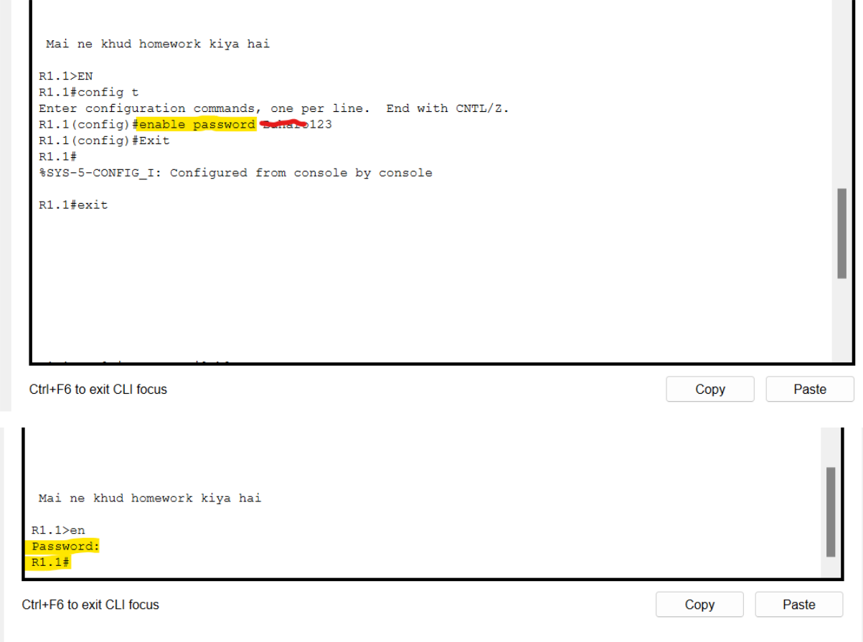

=>Secret (Encrypted) Password for Privileged Mode

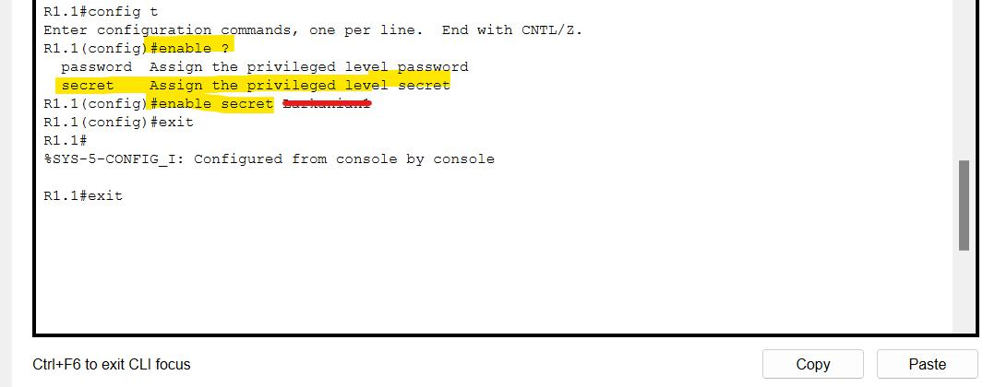

=>Auxiliary Line Password

The auxiliary port is commonly used to connect a modem. It is used to allow a remote user access to the configuration of the router. If modem is connected to port so port must have password.

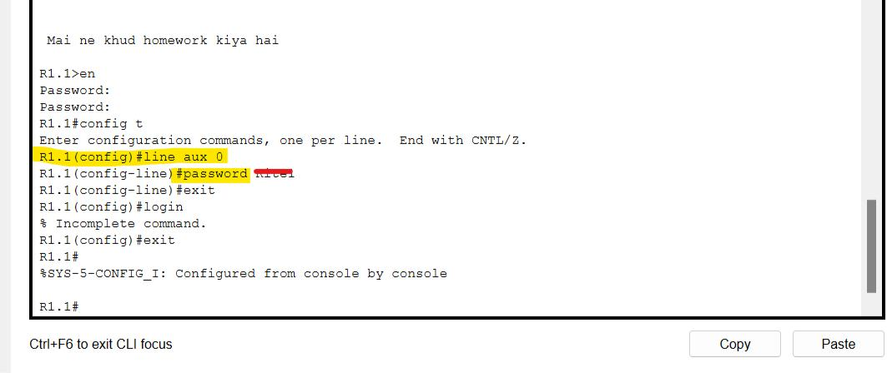

**TASK 7:** Line Console Password Implementation on CISCO 2600 Series Router

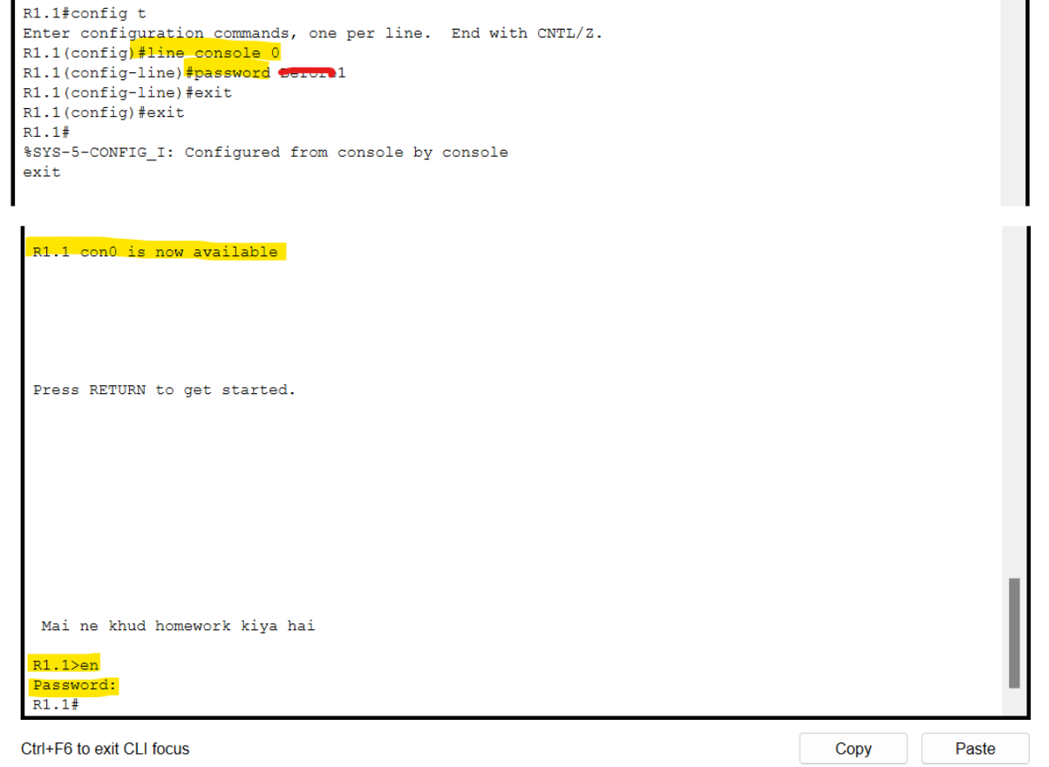

**TASK 8:** What is Telnet? How to Telnet? + Line VTY/Telnet Password.

**1)What is Telenet?**

Telenet(Teletype Network protocol) is a network protocol which is used to virtually access a computer. Telnet is a type of client-server protocol that can be used to open a command line on a remote computer, typically a server. Telnet isn't secure and shouldn't be used over the Internet.

**2)How to Telenet?**

1. Open **CMD.**
   1. Type **Telnet <IP Address> <port number>**
   2. If you see a blank cursor then the connection is fine. You can close the command prompt window.
2. **Line VTY/Telnet Password**

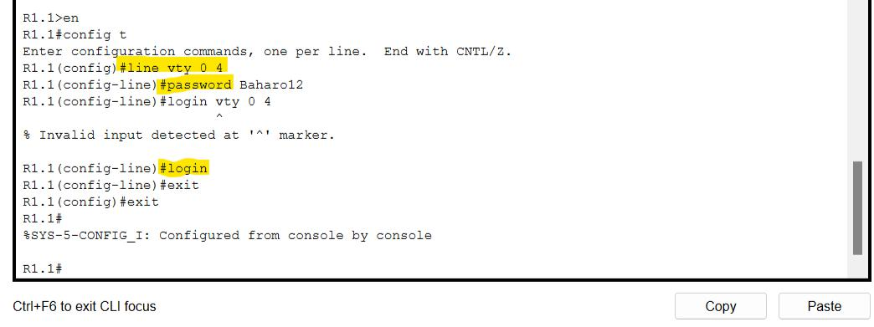

**TASK 9:** Usage of Router with different topology.

1)Star topology

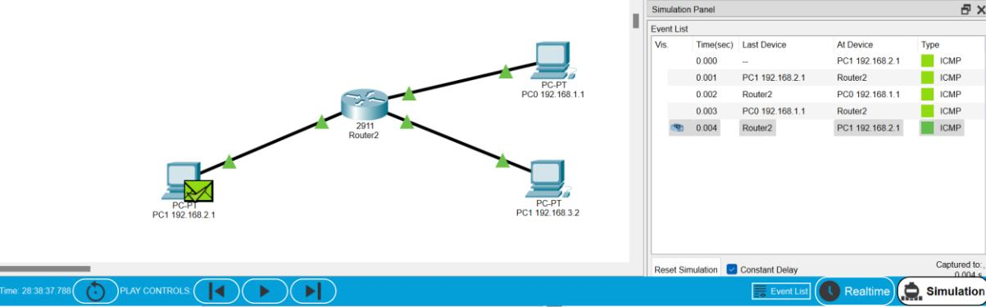

2)Full mesh topology

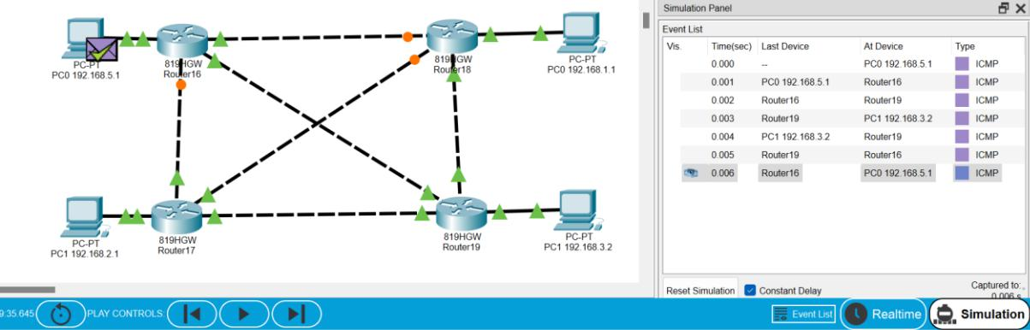

3)Bus topology

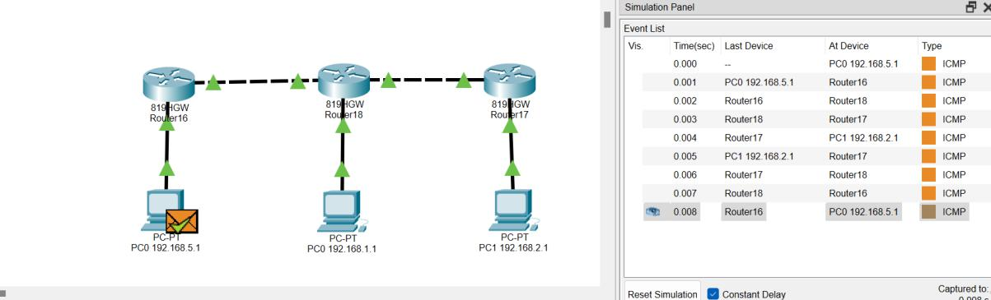

4)Ring topology

